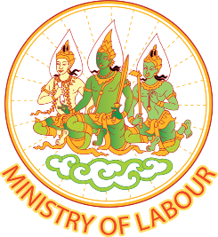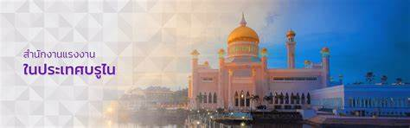

**Company need Thai Labour**



Office of Labour Affairs, Royal Thai Embassy Bandar Seri Begawan, Brunei

Thank you for you information